Subject: Software Development Technology

Project Work

**Working Experience   
in All Phases of Development**

**Involved In Creating a “Weather App”**

DQ4WX0 Takahiro Fujiwara

EQK6P6 Yasmine Trabelsi

Supervisor: Professor Krutilla Zsolt

University of Dunaújváros

2022.11.29.

**Change History**

|  |  |  |  |
| --- | --- | --- | --- |
| Date | Version | Modification | Contributor |
| 2022.11.25. | 0.1 | Initial version | Takahiro |
| 2022.11.26. | 0.2 | Add Further Dev | Takahiro |
| 2022.11.26. | 0.3 | Add Display Result | Takahiro |
| 2022.11.27. | 0.4 | Add Result for iOS simulator | Yasmine |
| 2022.11.27. | 0.5 | Update TDD Section | Yasmine |
| 2022.11.27. | 0.6 | Add Experiences | Takahiro |
| 2022.11.28. | 0.7 | Add Experiences | Yasmine |
|  |  |  |  |

**Table of Contents**

1. Overview 3

1.1. Application Image 3

1.2. Communication Diagram 3

1.3. Different points from the reference web program 4

1.4. Non-functional Requirements 4

2. Development Outline 4

2.1. Technologies for the Development 4

2.2. Development Schedule 4

2.3. Important issue of the Development and Test Environment 5

2.4. Xamarin.Forms Development Directory 5

2.5. Android Emulator 5

3. Development 6

3.1. Solving Web API Problem 7

3.2. Degree Celsius Conversion 7

3.3. Unit Display 7

3.4. Large Images related to the weather 8

4. Test-Driven Development (TDD) 9

5. Display Results 10

5.1. Android 9.0 (Pixel 3a) Emulator on Windows 10

5.2. Windows UWP 11

5.3. iOS Simulator on macOS 12

6. Possibilities for Further Development 13

7. Summarize of the Experiences 13

7.1. Takahiro Fujiwara 13

7.2. Yasmine Trabelsi 13

## Overview

This application shows the current weather from Weather Server, OpenWeatherMap ( <https://openweathermap.org/> ) Get the real time weather data from the weather server and show it on the display.

Other reference document:

<https://deanilvincent.github.io/2017/07/03/simple-weather-app-in-xamarin-forms-with-mvvm-using-weather-api-part1/>

### Application Image

This is an image sample, not a real. Some part will be changed (for example, temperature)

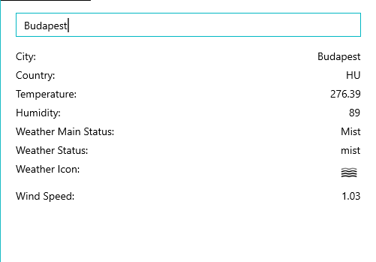

**SHOW**

### Communication Diagram

User

Specify a city and  
Display Weather

Weather Interface

Weather Server  
via internet

1: Specify a city

2: Generate API String

Result

Result with JSON format

J

3: Post API as HTTPS

4: Display Weather with value conversion

### Different points from the reference web program

* Reference program going to ask each letter input. E.g., in the case of Budapest,  
  type “B” then asking to internet server, type “u” then asking “Bu” …. So, add “Show” button and only after clicking/tapping that button, then going to ask to the Weather sever.
* Temperature number is not good. Change it to Celsius degree.
* Add units for example, Humidity: 89 -> 89%
* Show bigger picture for the weather.

### Non-functional Requirements

* Packaging / deployment work is not included for this project.

## Development Outline

Platform: Expecting to provide it as UWP/Android/iOS application.

Development Environment: Microsoft Visual Studio 2022.

### Technologies for the Development

|  |  |
| --- | --- |
| Technology | Purpose |
| Xamarin.Forms | Make available on Windows/Android/iOS. |
| MVVM model | Separate development with some developers. |
| Weather API | Get the current weather for each city in the world |
| Nuget Packages |  |
| Microsoft.Bcl.Build | Provides build infrastructure components so that projects referencing specific Microsoft packages can successfully build. |
| Microsoft.Net.Http | HttpClient for sending requests over HTTP, as well as HttpRequestMessage and HttpResponseMessage for processing HTTP messages. |
| Newtonsoft.Json | Handle JSON data easily |

### Development Schedule

|  |  |  |  |  |  |  |  |  |  |
| --- | --- | --- | --- | --- | --- | --- | --- | --- | --- |
| Task Working Day🡺 | 1 | 2 | 3 | 4 | 5 | 6 | 7 | 8 | 9 |
| Research | X | X |  |  |  |  |  |  |  |
| Original Implement |  | X |  |  |  |  |  |  |  |
| Feature – making button |  |  | X | X |  |  |  |  |  |
| Feature – Temperature conversion |  |  |  |  | X |  |  |  |  |
| Feature – Add unit |  |  |  |  | X |  |  |  |  |
| Feature – Add Image |  |  |  |  |  | X | X |  |  |
| Final Test |  |  |  |  |  |  |  | X |  |
| Documentation |  | X | X |  | X |  | X |  | X |

### Important issue of the Development and Test Environment

In this section, would like to show some of important thing for development and test.

OS version: Windows 10 Home 22H2

Visual Studio: Visual Studio Community 2022 (64bit) Version 17.4.1

Language: C#, XAML

### Xamarin.Forms Development Directory

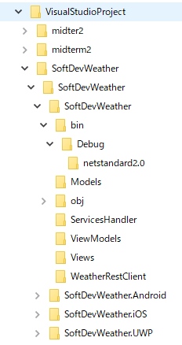

There are some restrictions which are found in the previous development.

* **Do not use longer folder name:** There is max file length and Xamarin.Forms development files are placed under the many of sub folders.
* **Do not use virtual drive:** There is unknown restriction at runtime.

So, the example of recommended way is to create a directory C:\VisualStudioProject and place a new project under that directory.

### Android Emulator

On the Visual Studio 2022, we can not run the emulator of the version Android 10 or later.

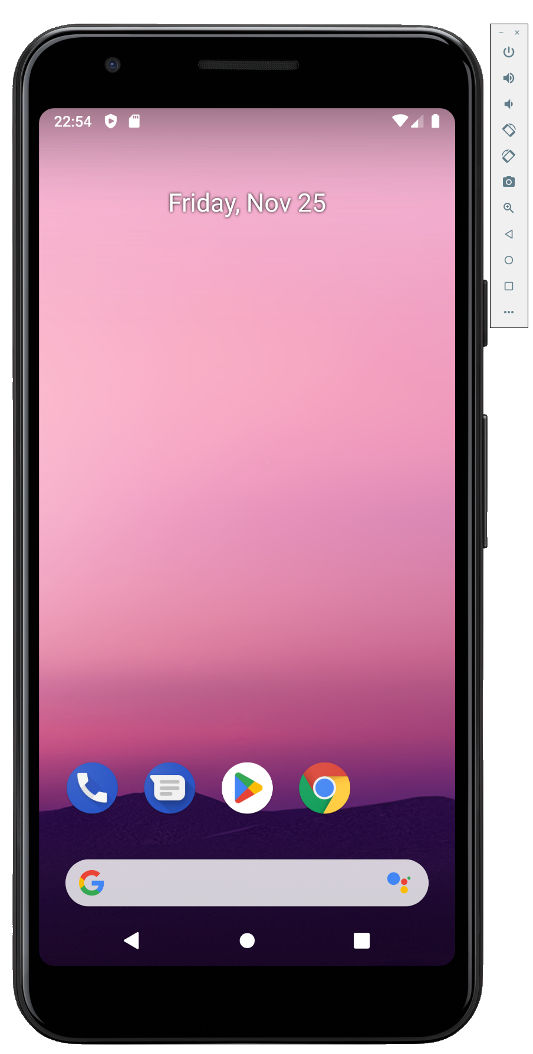

So, the example of recommended way is to create an emulator of Android 9.0 with the hardware: Pixel 3a. Pixel 3a emulator shows very similar hardware looks. Other hardware sometimes shows just a box window, it is not a problem but if we use Pixel 3a, we can be easy to recognize that this is an emulator of the Android Smartphone.

## Development

Here is the Class Diagram for all classes.

### Solving Web API Problem

It might be a common sense, but we did not know – many of web information is introducing that Web API starts with http:// and it works on UWP windows app.

However, we test it on Android Emulator, screen shows empty page and not able to get a return value from the Web API. There is a possibility of emulator environment problem. So, checked the internet connection using web browser on the Android emulator however, there was no problem.

So, we doubted the API string which is starting http:// because recent web browser refuse http:// connection and use https:// connection. At first checked it is okay on changing API to https:// on the UWP app which we are developing, and it was okay. Then next checked on Android Emulator and finally we could get the correct API result.

### Degree Celsius Conversion

The unit for the Temperature from the OpenWeatherMap is Kelvin.

So, the formula is just this:

Celsius = Kelvin – 273.15

However, we found that if the following parameter set to the API string, then return value will be Celsius. So, we chose this way.

[https://api.openweathermap.org/data/2.5/weather?q=*{city}*&appid=*{key}*&lang=ja&units=metric](https://api.openweathermap.org/data/2.5/weather?q=%7bcity%7d&appid=%7bkey%7d&lang=ja&units=metric)

### Unit Display

Add °C to the temperature, % to the humidity, m/s to the wind speed.

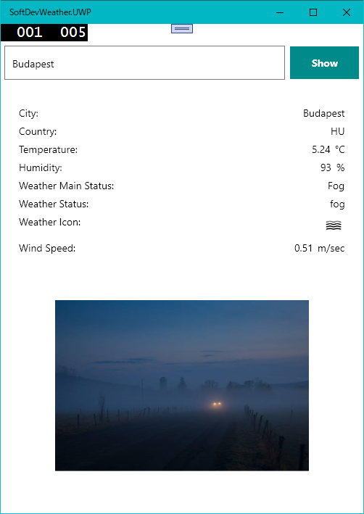

Original version

Update version

### Large Images related to the weather

The original weather app is using their icons and we would like to prepare another original picture, which we can get from free license picture. The original icons are 2 x 9 = 18 icons such as follows. It is little hard to prepare 18 icons therefore we will prepare only the day picture and if there is a night weather, we will use day picture, at the moment.

At first, we prepared Images folder and placed the jpg files, however it was hard to show it.

Finally, prepared as a web url, the same way to show it as OpenWeatherMap icon. This is also a merit of small packaging size. This app needs to connect to internet, that means the app is available only with the online mode, thus, getting picture from the internet is no problem.

## Test-Driven Development (TDD)

TDD approach means …. Yasmin please.

We used TDD approach for showing picture for each weather. Because the return weather is a possibility of unknown whether such as “Blizzard”, “Heavy rain” and the ICON file name is skipped but it looks 01 to 50 but the web site explaining only 13 icons. So, we need to test it as unknown weather.

## Display Results

### Android 9.0 (Pixel 3a) Emulator on Windows

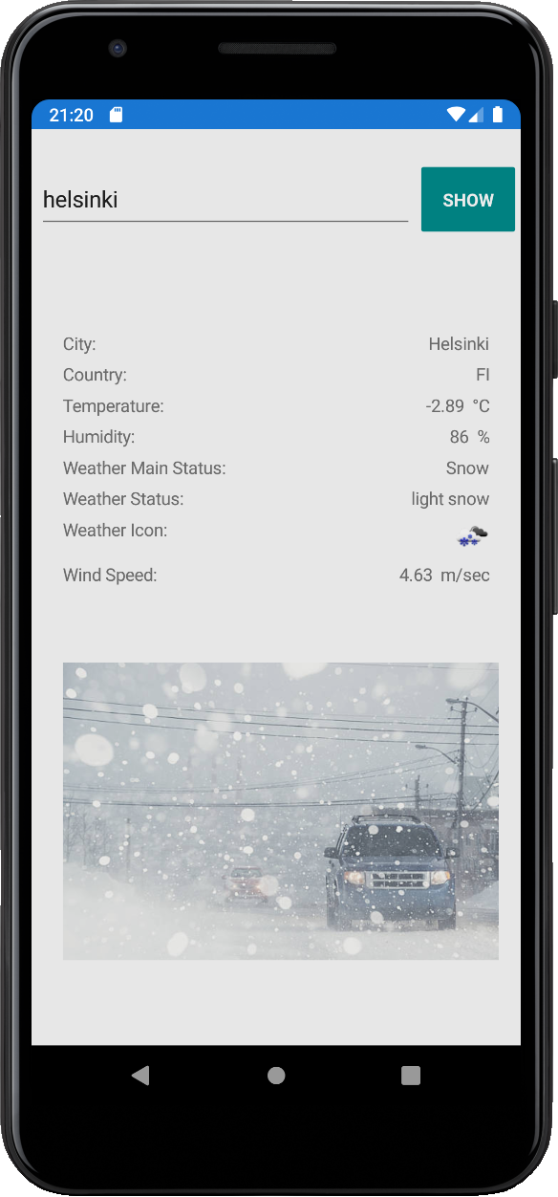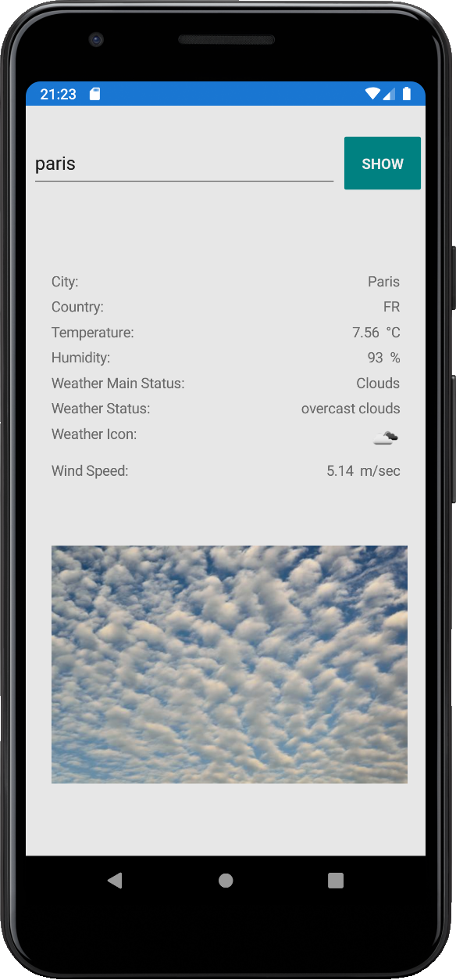

### Windows UWP

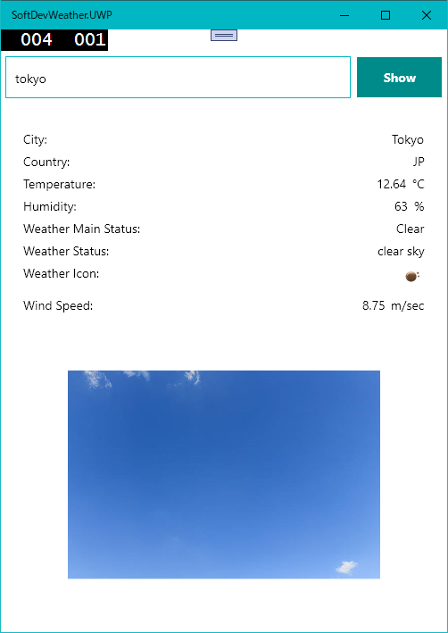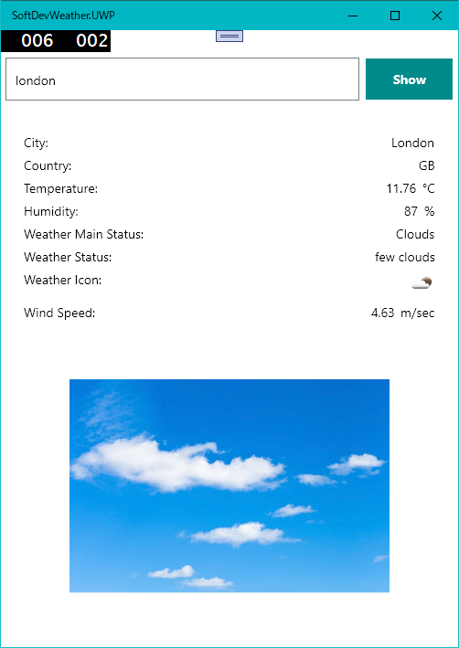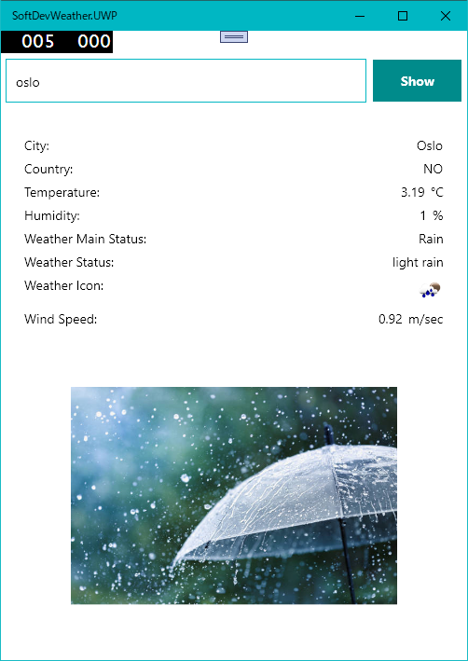

### iOS Simulator on macOS

We tried with the iOS Simulator.

However, there are some errors and not worked.

/Users/yasmine.trabelsi/.nuget/packages/microsoft.bcl.build/1.0.21/build/Microsoft.Bcl.Build.targets(5,5): Error: Could not locate /Users/yasmine.trabelsi/Downloads/SoftDevWeather 2/SoftDevWeather/SoftDevWeather/packages.config. Ensure that this project has Microsoft.Bcl.Build installed and packages.config is located next to the project file. (SoftDevWeather.iOS)

Actually, Microsoft.Bcl.Build is active however Microsoft.Bcl is deprecated. So, some maintenance is needed but we could not find the solution is these working days.

タイムライン

We would like to leave this issue as a future work.

## Possibilities for Further Development

We can add more feature to the weather application. For example:

* Store the cities which the user specified and easy to select it from a combo box.
* Show the world map with clickable points
* Connect the above specified city and the map. In this view, the weather icon is displayed with the city name on the appropriate position – need to use geographic location so it is harder.
* In the OpenWeatherMap, there is a function to get a weather forecast 5 days. So, we can add the forecast page for the city.

## Summarize of the Experiences

Here are our experiences.

### Takahiro Fujiwara

* Preparing development environment is very hard, especially Xamarin and emulator thing. Web information is not fit for the latest version of Xamarin and Android emulator, so It was very hard to solve it. However, we understood that when we got that environment, we can develop a cross platform applications, easily.
* It is new to me that using Web API and JSON handlings.
* Working days are not enough, especially this semester was hard due to the Autumn holiday is disappeared – all subjects are compressed.

### Yasmine Trabelsi